create table Salesperson(

Snum number(4) PRIMARY KEY,

Sname varchar2(10),

City varchar2(10),

Comm number(2,2));

insert all

into Salesperson(Snum,Sname,City,Comm) values(1001,'peel','london',.12)

into Salesperson(Snum,Sname,City,Comm) values(1002,'serees','San Jose',.13)

into Salesperson(Snum,Sname,City,Comm) values(1003,'motika','london',.11)

into Salesperson(Snum,Sname,City,Comm) values(1004,'rifkin','barcelona',.15)

into Salesperson(Snum,Sname,City,Comm) values(1005,'anelrod','new york',.10)

select * from dual;

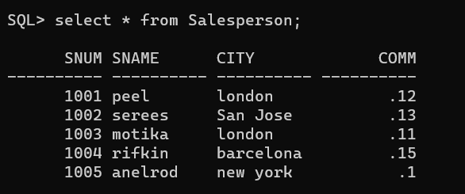

create table Customer(

Cnum number(4) PRIMARY KEY,

Cname varchar2(10),

City varchar2(10),

Rating number(3),

Snum number(4));

insert all

into Customer(Cnum,Cname,City,Rating,Snum) values(2001,'hoffman','london',100,1001)

into Customer(Cnum,Cname,City,Rating,Snum) values(2002,'siovanni','rome',200,1003)

into Customer(Cnum,Cname,City,Rating,Snum) values(2003,'liu','san jose',200,1002)

into Customer(Cnum,Cname,City,Rating,Snum) values(2004,'siass','berlin',300,1002)

into Customer(Cnum,Cname,City,Rating,Snum) values(2005,'climens','london',100,1001)

into Customer(Cnum,Cname,City,Rating,Snum) values(2006,'cineros','san jose',300,1007)

into Customer(Cnum,Cname,City,Rating,Snum) values(2007,'periera','rome',100,1004)

select * from dual;

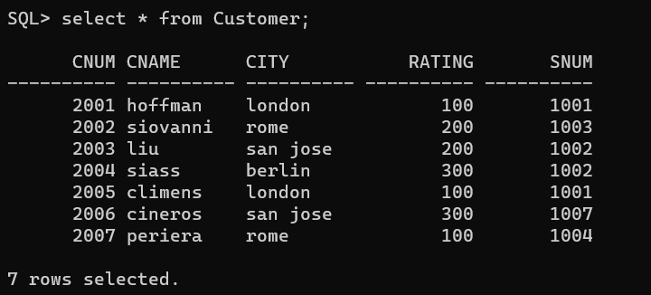

create table Orders(

Onum number(4) PRIMARY KEY,

Amt number(6,2),

Odate date,

Cnum number(4),

Snum number(4));

insert all

into Orders(Onum,Amt,Odate,Cnum,Snum) values(3001,18.69,'03-oct-90',2008,1007)

into Orders(Onum,Amt,Odate,Cnum,Snum) values(3003,767.19,'03-oct-90',2001,1001)

into Orders(Onum,Amt,Odate,Cnum,Snum) values(3002,1900.10,'03-oct-90',2007,1004)

into Orders(Onum,Amt,Odate,Cnum,Snum) values(3005,5760.45,'03-oct-90',2003,1002)

into Orders(Onum,Amt,Odate,Cnum,Snum) values(3006,1098.16,'03-oct-90',208,1007)

into Orders(Onum,Amt,Odate,Cnum,Snum) values(3009,1913.33,'04-oct-90',2002,1003)

into Orders(Onum,Amt,Odate,Cnum,Snum) values(3007,75.75,'04-oct-90',2004,1002)

into Orders(Onum,Amt,Odate,Cnum,Snum) values(3008,4723.00,'05-oct-90',2006,1001)

into Orders(Onum,Amt,Odate,Cnum,Snum) values(3010,1309.95,'06-oct-90',2004,1002)

into Orders(Onum,Amt,Odate,Cnum,Snum) values(3011,9891.88,'06-oct-90',2006,1001)

select * from dual;

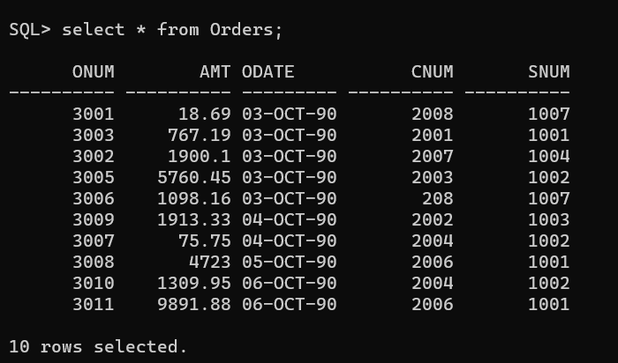

**Questions:**

1. Find the largest order taken by each salesperson

select Snum,Max(Amt) from Orders group by Snum;

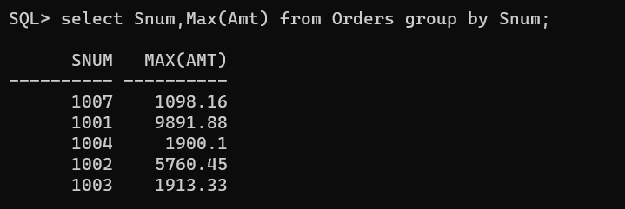

2. Find the largest order taken by each salesperson on each date

select Snum,Odate,Max(Amt) from Orders group by Snum,Odate;

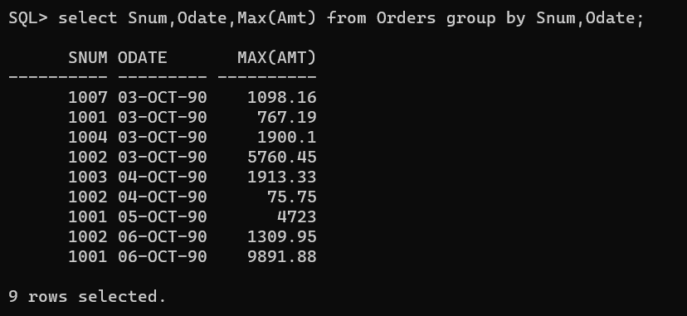

3. Find the maximum purchase over $3000 taken by each salesperson on each date

select Snum,Odate,Max(Amt) from Orders group by Snum,Odate having Max(Amt)>3000;

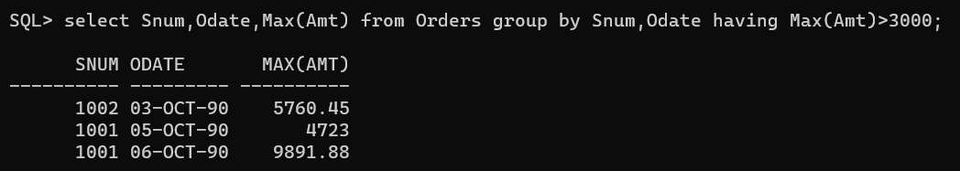

4. Find each salesperson maximum sell on 3rd October

select Snum,Max(Amt) from Orders where Odate='03-OCT-90' group by Snum;

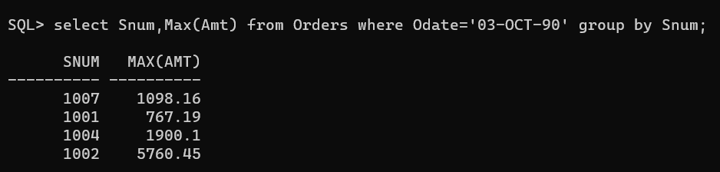

5. Find the largest order from Serees and Rifkin.

select Snum,Max(Amt) from Orders group by Snum having Snum in(1002,1007);

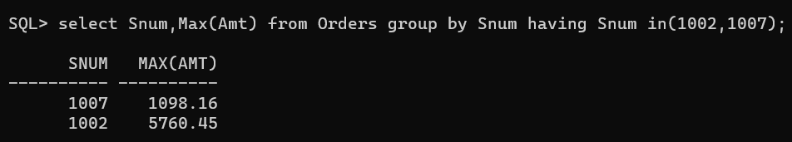

6. Count all orders for October 3rd

select count(*) from Orders where Odate ='03-OCT-90';

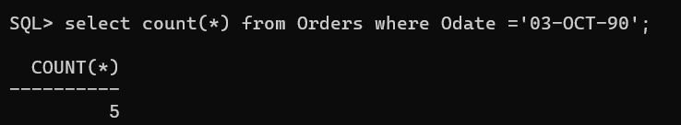

7. Count the number of different non null city values from customer table

select count (distinct City) as "no. of different non-null city" from Customer;

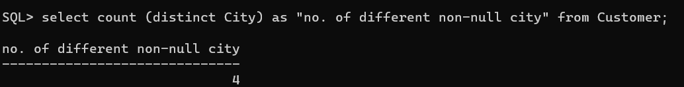

8. Find each customer smallest order

select Cnum,min(Amt) from Orders group by Cnum;

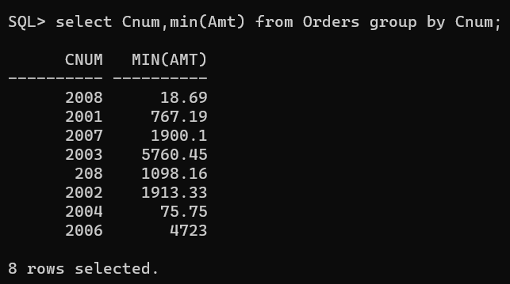

9. Find the first customer in alphabetical order whose name begin with G

select min(Cname) from Customers where Cname='G%';

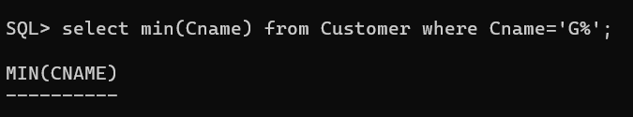

10.Find the highest rating in each city

select City ,max(Rating) from Customer group by City;

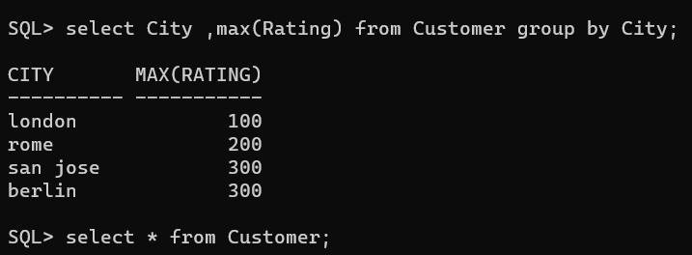

11.Find out which day had highest total amount order

